The Politicisation of the ‘Refugee Crisis’
Jack Bridgford

When news first broke of irregular migrant crossings over the Belarus-EU border, reports were quick to frame events in political terms. Headlines describing a ‘crisis at the border’ were made in reference to the geopolitical implications of Belarus’s actions rather than the suffering of thousands of displaced people.

The Belarusian case is just the most recent example of the overtly political character that the ‘refugee crisis’ has come to embody – not only in how it has been reported, but in its very inception.

Tensions on the Belarusian border

Belarusian president, Alexander Lukashenko, has been accused of using refugees to engage in ‘hybrid warfare’ in response to a new round of EU sanctions imposed in May 2021 for election fraud and repressing political opposition. Belarusian authorities are reported to have lured thousands from the Middle East into Minsk through false claims of easy entry to the EU and offers of tourist visas. From there, refugees were driven on state buses to the country’s borders with Latvia, Lithuania, and Poland (all EU member-states).

The EU adopted a decidedly firm stance, retaliating with further rounds of restrictive measures on Belarus, and refusing to admit migrants or process asylum applications. In breach of multiple obligations under European, human rights, and refugee law, the bloc has sought to stem any flow of refugees. Polish and Lithuanian authorities imposed a state of emergency near their respective borders, erected razor wire fencing, and instructed border guards to drive irregular migrants back into Belarusian territory.
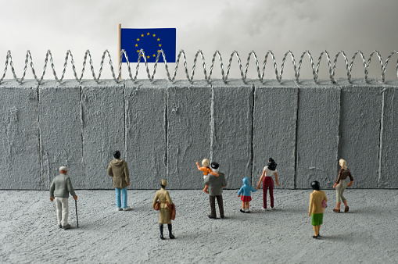

What is unfortunately lost amidst the tense political standoff is the human face of the crisis.
Pushed back illegally by Polish border guards, and coerced by Belarusian officials to cross again, thousands found themselves trapped in a dangerous game of ‘ping-pong’. According to reports, between 10,000 to 20,000 people suffered in freezing conditions, in circumstances which violated their human rights and endangered their lives. “Some migrants say Belarusian forces beat them if they fail to cross into Poland, turning them back toward the border and refusing them food or water”, wrote correspondent Loveday Morris in November 2021.

Even more troubling is the fact that this is not a standalone phenomenon; increasingly often, displaced communities are being held hostage to “selfish political calculations that view them as a burden or a pawn.”

Migration diplomacy

Over the past decade, the global system of refugee management has been fundamentally changed. Since 2011, the mass influx of migrants into the Global North, in particular the EU, has given rise to growing anti-refugee sentiment. Xenophobic rhetoric and dehumanised portrayals of refugee struggles in the media have helped create the perception of migrants as an aggressive burden. Discussions of the ‘refugee crisis’ have thus pivoted from humanitarian debates to issues of national security.

This has given rise to what Rawan Arar describes as, a new ‘grand compromise’. As states in the Global North have become increasingly determined to deter refugees and maintain sovereign interests, those in the Global South have been given new opportunities: extracting revenue or other concessions in exchange for keeping displaced groups within their borders.
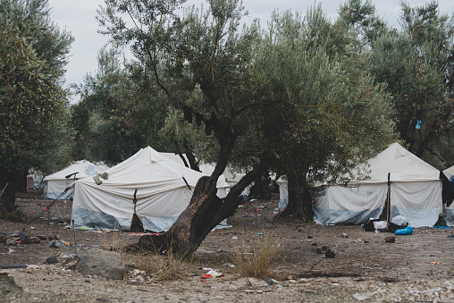

The EU-Turkey deal of 2016 is a clear example of this in action. Taking inspiration from Libya’s Gadaffi, who in 2010 extracted €50 million from the EU after dramatic threats to ‘flood’ Europe with African migrants, Turkish President Recep Tayyip Erdoğan gave similar warnings in February 2016. “We can open the doors to Greece and Bulgaria anytime and we can put the refugees on buses,” he declared to EU officials. Erdoğan’s ‘coercive migration diplomacy’ proved highly effective in speeding up negotiations. Turkey agreed to strengthen its border forces and return irregular migrants from Greece in exchange for an unprecedented €6 billion and promises to reopen discussions concerning its EU membership application.

This arrangement looks to endure in the future, with resurgent interest in renewing the EU-Turkey deal five years after it was first agreed. Speaking in Ankara in April 2021, President of the European Commission Ursula Von der Leyen reaffirmed her commitment to “ensuring the continuity of European funding in this area.”

Instrumentalization of the refugee problem

The proliferation of migration deals such as the EU-Turkey accord and compacts with Jordan and Lebanon should be a cause of great concern. They have already set a dangerous precedent, encouraging major refugee host states to commodify their refugee populations as sources of ‘economic rent’ and even weaponize them in the pursuit of strategic objectives.

Examples of states cynically instrumentalising the migration issue abound. Soon after the EU-Turkey accord was put into effect, the Kenyan government threatened to close its Dadaab camp to secure funding – a move which would have involved the displacement of 245,126 refugees.

The Turkish government itself has looked to leverage its position as a host state, even after the €60 million deal. In both 2019 and 2020, President Erdoğan engineered refugee crises to pressure the EU into supporting Turkish military campaigns in northern Syria and make good on its funding commitments. Turkish authorities declared the border to Greece open for the millions of refugees in the country and facilitated thousands of migrants from refugee camps to reach the Greek border.

Morocco employed similar tactics in May 2021 when officials organised a mass border crossing into the Spanish territory of Ceuta. In response to the Spanish government’s decision to give medical treatment to a leader of the Polisario Front, (a prominent separatist movement in the country), over 8,000 people were helped cross into the European enclave.

The continuation of such exploitative practices is both unsustainable and morally unconscionable. As has already been observed on the Belarusian border, displaced groups caught in the middle of volatile geopolitical disputes are denied effective protection and subject to human rights violations including arbitrary detention and the denial of access to medical attention, legal representation, and asylum procedures.

Final thoughts

Pope Francis’s comments in response to events on the Belarus-Poland border are pertinent: "How can suffering and despair be exploited to advance or defend political agendas? How can political considerations prevail when it is the dignity of the human person that is at stake?"

Refugees deserve respect, rights, and safety. It is thus imperative that we resist highly politicised discourses which frame refugees in large, anonymised groups – as a threat to national security, a drain on resources, or as leverage to secure selfish, geopolitical aims. More than ever before, there is a genuine need to humanise the suffering of refugees and reframe the ‘refugee crisis’ as an issue that demands compassion and global cooperation.

Equally pressing is the need to liberalise the migration system. As long as states in the Global North are allowed to externalise their border security and reward host states for serving as buffer zones, refugees will continue to suffer as pawns in deadly geopolitical games.
